Inspiration:
1) Depending on your project (print or video) use the following media texts as inspiration. You need to ANNOTATE the images and note down how ideas are being communicated, desire created, the demographic and differentiation achieved. You can also note down anything that you may wish to use in your own project and what you don’t like.
2) Then, find other ads, they don’t need to be selling water and complete the same process.

Video:
- Mt Franklin: https://www.youtube.com/watch?v=zereMcc06zk&spfreload=10
- Cool Ridge: https://www.youtube.com/watch?v=mzecQi0zkvY&spfreload=10
- Evian: https://www.youtube.com/watch?v=XQcVllWpwGs
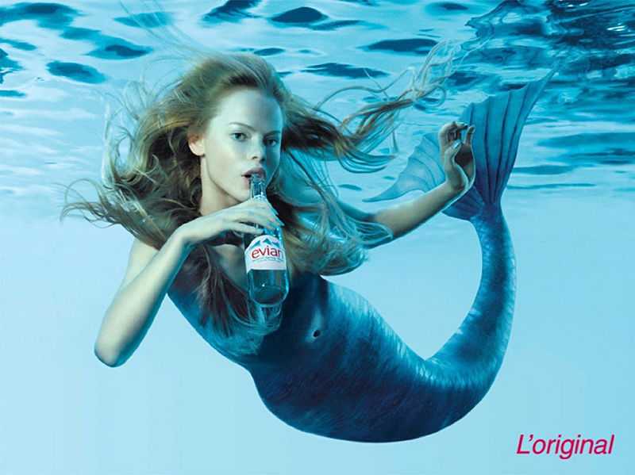
Tap water: https://www.youtube.com/watch?v=VLBfaWnpSgs&spfreload=10
Print:
