Story Elements
As production elements are the technical codes that communicate meaning in a narrative, story elements are the symbolic codes that drive the narrative.
Task 1: Memorise the seven story elements and their definitions
Simple term | Detail explanation of element (definition)
Opening, development and resolution of the narrative | This refers to how ideas and issues are established in the context of the opening sequence and compounded throughout narrative development, and whether they are resolved at the end.
Setting | The setting of a narrative is the general location of the action. The setting usually reinforces the action, they are designed to complement and strengthen what the audience sees and the meaning created.
Character and Character relationships | This includes motivations, what they say, do and how they interact and relate to each other. It also deals with the way look, act and function with a setting, scene or frame. It is also important to understand the similarities and differences between characters and their relationships.
Cause and Effect | Cause and effect constructs and develops narrative progression, from the initial event that triggers a narrative, through a series of subsequent linked events that develop the plot to its resolution. A text usually begins with one event or situation, something happens to alter or change it (cause and effect).
Structuring of Time | Time looks at the order and structure in which events occur, how long they occur for and how often. Many films also deal with time in a non-linear way, meaning the events do not happen in sequence, but jump forward or backwards in time during the film.
Point of View | The point of view from which the narrative is presented. In most narratives, one characters point of view is privileged over another.
Multiple Storylines | Multiple storylines are common in a narrative film. While most narratives follow one storyline closely, it is common for backstories or complementary stories to run concurrently.

Task 2:
Opening, development and resolution of the narrative:
This refers to how ideas and issues are established in the context of the opening sequence and compounded throughout narrative development, and whether they are resolved at the end. In a majority of texts, there is more than one possibility. This is how the director engages an audience. The opening sequence is important in setting up characters and their relationships for the rest of the film. It introduces the setting and its relationship to the characters. This means you gain an understanding of where the storylines may lead. It is important to understand the relationship between the opening and closing sequence, and how the narrative progressed between them. The closing sequence provides closure for the film. It is when the story is finished, and the issues are ‘tied up’ or dealt with. However, not all narratives are conveniently resolved. An example of this is a cliff hanger, or an obvious lead to a sequel.
Practice exam questions:
Question 1:
Describe how a production element is used to communicate meaning and engage the audience in the opening sequence of a text you have studied this year. (5 marks)
Question 2:
Explain how ideas that are introduced in the opening scene are resolved in the final resolution. (6 marks)
Task 3:
Setting:
This contributes to the narrative as it is important to help create the atmosphere. The setting also adds relevance and realism within a scene. If you look at typical horror films, they are usually set in places that are deemed scary, such as graveyards or very old mansions.
Practice exam questions:
Question 1:
Explain how the setting of the text you have studied this year contributes to the audiences understanding of the narrative.
Question 2: Compare and contrast two or more settings in one of the narrative texts you have studied this year. (5 marks)
Task 4:
Character development and/or relationships:
There are four aspects to the study of character. They include establishment, development, motivation and relationships. It includes what they say, do and how they interact and relate to each other. It also deals with how they look, act and function within a setting, scene or frame. It is also important to understand the similarities and differences between characters and their relationships.
Story, production and audience elements work together to bring characters to life. Directors select from a rich palette of techniques to establish character. Those early moments are very important- audiences can be fickle and make up their minds about characters in seconds. Setting, costume and props also provide also provide clues to establish character. Dialogue, music, voiceover and sound effects are also likely to be used.
In many narratives characters are established as stock or common characters. This is particularly the case in genre texts. Audiences recognise character types: the good guys, the loner, the femme fatale, the innocent abroad, the geek. Stock characters allow a director to assume that the audience has some pre-existing knowledge and experience of this character type, they use this knowledge to cut straight to the plot without having to develop each character in detail.
Directors position audiences to relate to characters in a particular way. This occurs even before the film begins, when an actor is cast for a part.
Practice exam questions:
Question 1:
Using two or more production elements explain how a character relationship between two characters in a text you have studied this year. (5 marks)
Question 2: Consider the main motivation of one of the characters, explain how this goal is communicated to the audience and how it drives the narrative. (8 marks)
Question 3: Compare and contrast the characterization of two characters in one of the texts you studied this year. Use production elements to support your analysis. (8 marks)
Task 5:
Point of View:
Who is telling the story? Which character is directing the narrative? What information are they giving us about the story, and what might they be withholding deliberately throughout the narrative? You also need to consider that point of view may not always be from a character, but other areas of the text or even the audience. In most narratives, one character’s point of view is privileged over others. More is revealed about this character than others through the story and production elements such as, narration, flashbacks, POV shots, and acting. Point of view may be omniscient; that is, the director gives an audience greater knowledge than that of the characters.
Practice exam questions:
Question 1:
Describe the point of view of which the film is established. (4 marks)
Question 2:
Explain how point of view works to establish the genre of the film. (5 marks)
Task 6:
Multiple Storylines:
This refers to the main storyline and ones that develop or stem from it. It involves any conflicts or resolutions, motivations or ideas that come from the main storyline. There are generally multiple storylines within a narrative. You should also be familiar with how storylines connect or differ from each other, depending on what happens. Some stories are related, even if they’re not dealing with the same characters, which others are not connected at all, but just exist within the same film.
Practice exam questions:
Question 1:
Describe how multiple story lines are presented in one of the narrative texts you studied this year. (5 marks)
Question 2:
Explain how multiple storylines contribute to the establishment of a character in one of the texts you studied this year. (5 marks)
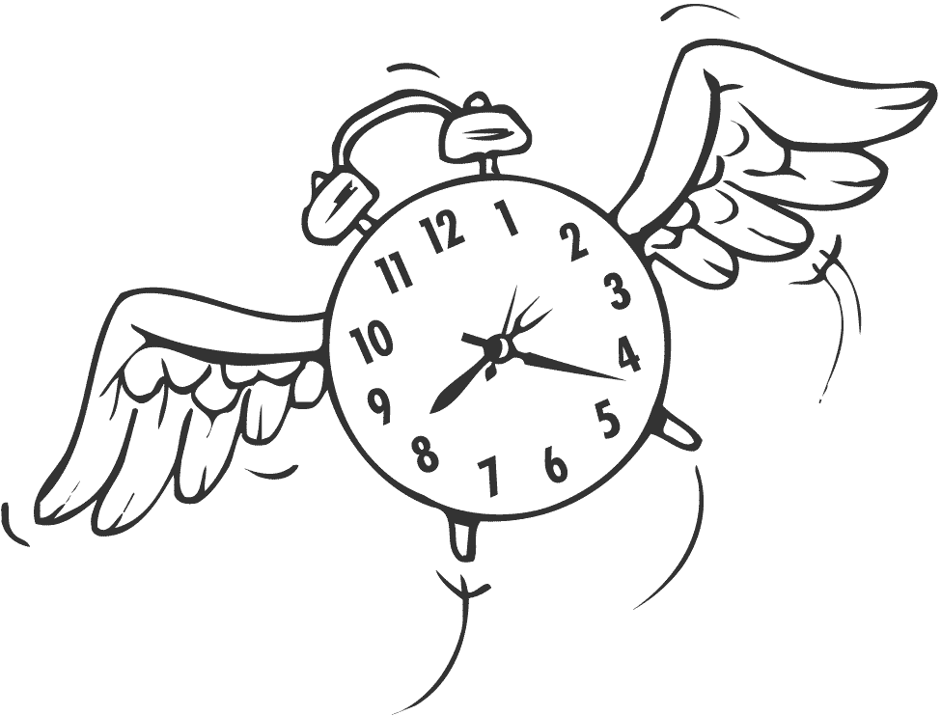
Task 7:
Structuring of Time
The subject of time and its relationship within the film is a very important issue. Time looks at the order and structure in which events occur, how long they occur for and how often. Many films also deal with time in a non-linear way, meaning the events do not happen in sequence, but jump forward or backwards in time during the film. These jumps are known as flashbacks or flashforwards. You should also understand that a majority of films do not run in real time. They do not cover every minute of the action. They will omit sections that are not relevant or mundane. How time is dealt with and presented to the audience can have a huge impact on how it is interpreted.
Practice exam questions:
Question 1:
With reference to one text, discuss how editing of vision and/or sound is used to structure time within the narrative. In your answer you may include discussion of style, techniques, placement, pace and rhythm of editing. (4 marks)
Question 2:
Explain how does the point of view of the text contribute to the establishment of genre. (4 marks)
Task 8:
Cause and Effect:
A text usually begins with one event or situation, something happens to alter or change it (cause and effect). Finally a new situation arises as a consequence, which end the narrative. If this happens then that happens. This also looks at character motivation, including desires, aspirations and problems. Why did the character do things in a certain way?
An example of a cause and effect text follows:
She got up on Saturday morning to play basketball (cause). After basketball she went straight home because she was tired (effect). And so she watched TV to relax (cause) which in turn made her tired and she had to go to bed early (effect).
Practice exam questions:
Question 1:
Discuss how cause and effect contributes to the development of the narrative. (5 marks)
Explain how the cause and effect of the narrative contributes to the character development in your narrative. (6 marks)

