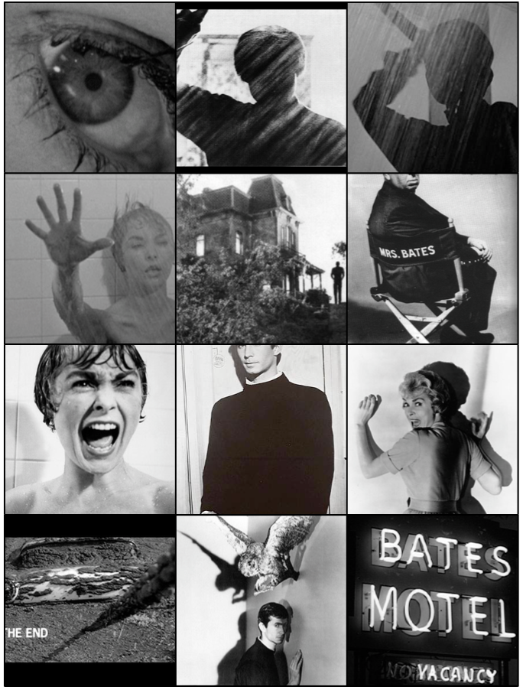
Name: ____________________________________
10 media
Film Analysis
Production Elements (CAMELS)

Camera Techniques
Define: Camera techniques refers to how the camera is positioned to capture a scene, and the techniques and qualities that are used. It may be from different angles, or from a distance, or it may be moving. It is also about the depth of field, focus, shot selection and film stock.

Shot Size
- Establishing Shot/Extreme Long Shot. Establishing shots are often used at the beginning of scenes to establish the setting. At the beginning of a film, for example, you might see an extreme long shot of a city. Then, we might cut to a closer shot of a street, then a building and finally the character inside.
- Long Shot. A long shot is where you can see characters but the frame is largely filled with the background.
- Full Shot. A character filmed from head to toe.
- Mid Shot. A character filmed from the waist up.
- Close Up. Usually a shot of a character’s face.
- Extreme Close Up. Extreme close ups are usually an attempt to draw the viewer's attention to a particular detail. For example, the director may choose to cut from a mid shot of a character to an extreme close-up of a gun in his hand.
Camera Angle
- Overshot. The camera is positioned directly above the subject. This is often used in establishing shots, where the camera flies over city streets..
- High Angle. The camera is positioned above the subject, looking down at an angle. This angle makes the subject appear smaller, powerless and more vulnerable.
- Eye Level. This is the most commonly used camera angle in film and television. The characters appear at eye level.
- Low Angle. The camera is positioned below eye level, looking up, to imply a sense of power and dominance.
- Undershot. The camera is positioned directly beneath the subject, looking up. Often coupled with point-of-view shots when the character is looking up at something.
Camera Movement
- Dolly. A dolly is any sort of moving platform that a camera is mounted on. Professional camera crews often lay down tracks which the camera can be moved along. Sometimes, the camera is mounted in the back of a car. Skateboards, office chairs and supermarket trolleys are the dollies of choice for low budget camera crews. Dollies are often used in very subtle ways. Throughout the course of a conversation, for example, you may notice that the camera very slowly moves closer to the characters.
- Tracking Shot. Any sort of shot where the camera follows a moving subject.
Pan. The camera turns horizontally when mounted on a tripod.
- Tilt. The camera tilts up/down when mounted on a tripod.
- Crane. The camera is mounted on a crane, helping filmmakers to achieve dynamic overhead shots.
- Handheld. Handheld camera movement is often used to achieve a sense of realism. Handheld camera movement achieves a sense of realism partly because audiences associate this sort of camera movement with documentary film.
- Steadicam. A device that allows camera operators to achieve smooth, fluid camera movement even when moving quickly across rough terrain.
- Zoom. The lens of a camera is used to magnify an image.
Acting
Define: Acting refers to specific characterisations, traits or associations that an actor will add to the character to create a personality. It includes: body language, facial expressions, appearance, gesture, and movement.
**When discussing acting always refer to the actor’s name, not the characters name.
Acting also makes an important contribution to the narrative of films. While an extreme close up may show an actor’s face, it’s up to the actor to convey their emotions to the audience.
- Body language. This is how the actor communicates with their body.
- Facial expressions. This is the expression that the actor creates emotion on their face.
- Appearance. This is the physical appearance of the actor.
- Movement. This is how the character moves in the scene.
- Voice. How the actor manipulates their voice to convey meaning.
- Casting. This is the association that the particular actor has.
Mise-en-scene
Define: Mise en scene incorporates many aspects. This is the way a scene, or particularly a frame is set up. It is how the director places the characters, props or setting to create a look. Take into consideration: colour, costumes, lighting, shots, setting, camera techniques.
** When analyzing mise en scene you must discuss 2 or more elements.
Mise en scene is a French term that refers to 'putting into the scene'. Whereas visual composition usually refers to how specific elements are arranged, mise en scene is a broader term that refers to the artistic look and feel of a shot. It encompasses a range of elements, including lighting, costume, make up, camera techniques and the positioning and movement of actors.

- Symbols. The symbolic meaning behind anything in the frame.
- Colour. The associated meaning of particular colours.
- Lighting. How light is constructed to convey meaning
- Camera. How the camera is positioned to create meaning.
- Space within the frame. How characters and objects are positioned in the frame.
- Props/set. The objects in the frame and the location of the action
- Costume/Makeup. What characters are wearing, how they are wearing it and their hair and make up.
Editing
Define: Editing deals with the way shots are put together, or cut to create the effect that the director wants. It is about placement of scenes, timing, pace and rhythm and the relationship between vision and sound.

Films are composed of shots which are edited together to tell a story.
- Cut The most basic edit. One shot is replaced by another. There is no transition between the two.
- Fade In. The screen is black, a shot gradually appears. Often used at the beginning of a sequence.
- Fade Out. An image gradually fades to black. This is often used at the end of a sequence
- Long take. A shot in a film which lasts longer, without a cut, than normal.
Lighting
Define: Lighting involves creating realistic light, shadows, emphasising objects and people within a scene, natural lighting, and expression and setting a scene. It can also be used to create mood.

Lighting is often used to give the audience information about characters. For example, evil characters are traditionally shot with low key lighting to make them appear sinister. Low key lighting is often used to engage audiences, particularly in horror films.
- Key Light. The main source of light.
- Fill Light. A light which makes areas in shadow more visible.
- Back Light. A light source positioned behind the subject, often obscuring and creating a sense of menace.
- High Key. Few shadows and little contrast. Often used in television sitcoms. Uniform lighting allows scenes to be shot quickly without repositioning lights.
- Low Key. Creates a ‘chiaroscuro’ effect, a strong contrast between light and dark areas.
- Naturalistic lighting. Artificial lighting that simulates what audiences would expect to see in the real world and constructs a sense of realism in a text.
- Expressive Construction of the lighting design intended to deliberately and non-naturalistically emphasise or draw attention to mood, character, location, ideas and/or themes.

Sound
Define: This includes sound track, music, sound effects, diegetic and non diegetic, dialogue, pitch, timbre, duration, rhythm and silence. It is used to create mood, atmosphere, convey emotions of characters.

Filmmakers think very carefully about the sound that they put in their films. Sound incorporates every aspect of the soundtrack - including sound effects, music and dialogue. Sound is always used to tell the story. Often sound effects can help tell us about the setting of a film. Music is one of the key techniques used to tell audiences how to feel. When watching films we are often encouraged to feel a sense of excitement or romance or adventure simply through the effective use of music.

- Diegetic sound. Sound that comes from the world of the narrative, that the characters can hear.
E.g. dialogue, sound effects, footsteps etc
- Non-diegetic sound. Sound that does not come from the world of the narrative. The characters cannot hear it. Eg. Soundtrack, narration etc
- Internal diegetic sound. Sound that is from the character’s mind, and can only be heard by one character, internal monologue. Eg. An internal monologue.

Task1:
Understanding the plot.
The plot is the main events that take place in a narrative. Usually, narratives will be broken up into three stages, the opening, developing and resolution.

Draw the following table in your workbooks and list the main scenes/events that occur.
 | Opening | Developing | Resolution
Main scenes
Extend yourself Make a list of conventions of a horror film, think about the production elements while you do this. Which of these does ‘Psycho’ use? Provide a brief example for each.
Task2:
Understanding the characters.
Characters and Actors
Anthony Perkins, as Norman Bates
Janet Leigh, as Marion Bates
Martin Balsam, as Milton Arbogast
Lila Crane, as Vera Miles
Sam Loomis, as John Gavin
John McIntire, as Sheriff Al Chambers
Choose three characters from the film and list 3-5 adjectives to describe them.
For each of these characters choose a key scene and describe how this scene gives insight into each character.
Draw a frame (that is a shot from the film) that you think is important in giving the audience information about a character. Annotate the frame and explain how it is important in creating that character.
Extend yourself Choose a relationship between two characters in the film. Eg. Sam and Marion, Norman and his mother etc, and describe how one scene gives insight into their relationships.

Task 3:
Writing in Media
When analyzing production elements, there is a simple structure to follow.
ORIENTATE: Briefly state the scene you will analyse.
NAME: Name the element you are analyzing.
DESCIBE: Using film language, describe the element.
LINK: Link this description to WHY you think the director has constructed the element this way and how it is meant to make the AUDIENCE feel or think.

You can even do this by FILLINF IN THE GAP! For example,
In the _(orientate)_ scene, the production element _(name element)_ is _(describe element)_. Hitchcock has constructed this to communicate the idea that _(Why)_ to make the audience think/feel (audience).
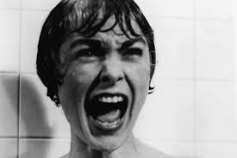
Let’s think about the production element, acting.
Here, Janet Leigh’s acting tells the audience that she is terrified, and what is happening to her is unexpected. Her mouth is wide open, her forehead furrowed and her eyes squinting. She is also screaming in a very loud high pitch tone.

Using the information in the dotted box above, write an ‘ORIENTATE, NAME, DESRIBE, LINK’ about the shower scene. Remember to use the earlier pages in this book to help you with your film terminology.
Extend yourself Choose a different scene and if you want, a different production element and write a ‘ORIENTATE, NAME, DESCRIBE, LINK’ statement of analysis.

Task 4
Lighting
Hitchcock constructs the lighting in the film, to create the mood of paranoia and suspense.
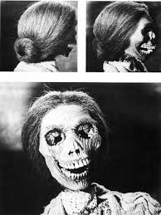
In this climatic scene, lighting is key to evoking emotions from the audience.
Using film language words (remember the previous pages of this document), describe the lighting in this scene.
Explain why you think the director has constructed lighting in this manner. What do you think Hitchcock’s purpose is?
Extend yourself Describe another scene from the film and explain the purpose of this lighting.

Task 5
Camera Techniques
Hitchcock uses the camera to communicate a lot of information and emotion to the audience.
For each of the three sub-elements of camera techniques identify an example from the film and explain WHY Hitchcock has constructed this, and the idea it communicates to the AUDIENCE.
 | Shot Size | Camera Angle | Camera Movement
WHY
AUDIENCE

Task 6
Mise en scene
Remembering what we covering in class, choose your own scene from ‘Psycho’ to annotate.
Choose 4-5 sub elements, (remember to read the information on the first few pages to help you remember what these are).
In regards to that image you have analyzed, answer the following question:
Describe how the production element mise en scene engages the audience or contributes to the narrative in the film ‘Psycho’.
GO FURTHER Have a go at answering the following question:
Explain how the production element mise en scene words with the other production element sound to establish the genre of the films.
Task 7
Editing, Sound, Acting
Read through the information about editing, sound and acting.
For each of the production elements of sound, editing and acting, choose 2 or more of the key words and complete the table below. These are the words that are dot pointed on the first few pages of the document.
Key word | Definition | Example from film | Meaning created
GO FURTHER Write a ORIENATATE, NAME, DESCRIBE, LINK for each of these elements.

