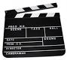
UNIT 2 Media
Production Design Plan (PDP)
Contents
What is it? 3
What needs to be in it? 4
Intention Statement 5
Audience Statement 5
Style and Genre 8
For the Film Makers 11
For the print and photography people 13
Assessment of your SAT 17

What is it?
An organised document that is made up of all of the pre-production planning for your product.
What isn’t it?
It’s not a visual diary, such as one you might do in Studio Art or Art. Therefore, you don’t include pages and pages of ideas.
every student in this class. Finally, there are extra additions that individuals can make who are hoping to achieve in the top grades for this subject.
What needs to be included?
FILM / DOCUMENTARY

Intention
Audience
Techniques for how you will engage your audience
Style and/or Genre
Storyline or outline of content
Script
Storyboard
Shot List
Location
Edit details and transitions
Lighting
Music and/or Sound Effects
Titles and credit sequences
Production Timeline
Export settings and details of reception
Main character descriptions and casting choices
Equipment that you’ll use and the stylistic reasons for your choice
Short interviews with members of your potential audience about your idea and any feedback they give you that you will incorporate
Costume and any relevant set design/ prop sourcing

Intention Statement
What it is:
This is a 300-500 word statement that articulates the purpose and overall concept for your media product. In your intention statement you may address the following dot points:
- What ideas, concepts, themes or issues do you want your product to explore?
- What do you want people to think about or consider when they engage with your product?
- Why are you making this product? What purpose does it serve? (aside from being a school assignment!)
- What other work has inspired this product?
- What conventions would people need to be familiar with to appreciate this product?
- What symbolism and/or motifs are you using in your work and for what intended purpose?
What isn’t it:
This isn’t a place to document the entire storyline of your video or to describe in detail each and every one of your photographs (there will be plenty of time for that later!)

Audience Statement
What it is?
This is one of the most important aspects of your PDP.
This is a 300-500 word statement articulating your target audience/s. It should include a description of who they are, what their expectations and knowledge might be and why they would be engaging with your media product. In your audience statement you might address the following dot points.
- Some key demographic information (eg. age, gender, where they live, income levels etc.) *note. sometimes not all of these are relevant but most of the time they are so be specific, it’s ok if you feel like you’re stereotyping because in a way that’s what you are doing.
- What other media forms and texts does your audience engage with?
- What knowledge does your audience bring with them? What conventions etc. are they aware of and expecting from your product?
- What aspects of your media product will they engage with and why?
What it isn’t
This isn’t a brief generalisation eg. ‘my target audience is anyone who loves to experience love and passion’.
Example
Straight up, let us know what media form you are working in and what genre/style.
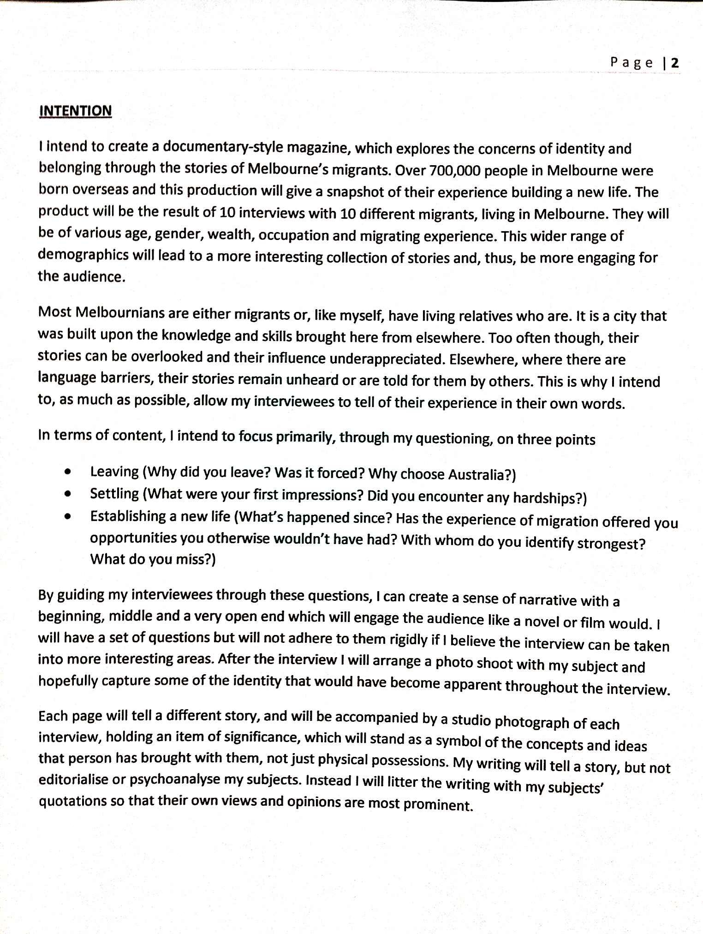
Give a rationale for why your concept is important/interesting
Sometimes it’s useful to point out what you are NOT on about, in order to clarify your concept to a reader
Feel free to use dot points to quickly and succinctly outline some key ideas
Statement by Mike Matters, NHS Media
Example
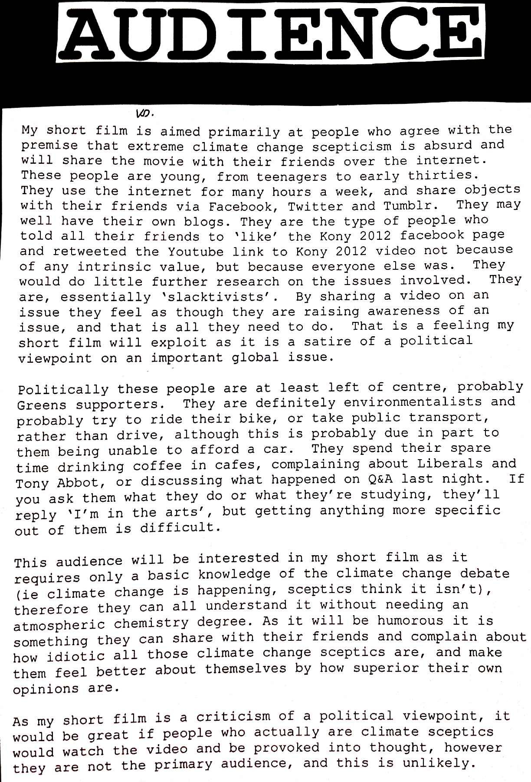
Explain why you audience will be interested in your product.
Political views may be relevant
Does your audience belong to a group that is commented on in the Media. ‘rev-heads’, ‘hipsters’
Use specific examples to help highlight your audiences activities.
Discuss what other media your audience uses and how they engage with it
Statement by Lucy Foskey, NHS Media

Style and Genre
What it is
This one is tricky and some people have a great deal of trouble with it so hopefully this makes it clear to everyone. Style refers to a particular appearance or procedure for how something is done. It refers to the manner in which it is done as separate from its content.
In media, there are visual styles which share common conventions and therefore look as though they belong together.
So, what is Genre? Well, genre is a category of a media form that shares common conventions. These are categories that don’t just share a style but also might share content.
Some ways to talk about style
Type of style | Examples
Stylistic technique | Handheld camera, chiaroscuro lighting, long takes, desaturation, black and white, panoramic, naturalistic, lomography
Stylistic movement | Film noir, Surrealism, German Expressionism, French New Wave
Noted media practitioners who have established styles | Hitchcock, Burton, Tarantino, Gilliam
Other words to describe style | Bohemian, romantic, industrial, eclectic, cold, warm, grungy, chic
Some ways to talk about genre
Media form | Examples
Film | Sci-fi, rom-com, western, indie, comedy, dramedy, thriller, horror

Example
There’s a few different ways you can do this. Some people describe the genre like the example below.
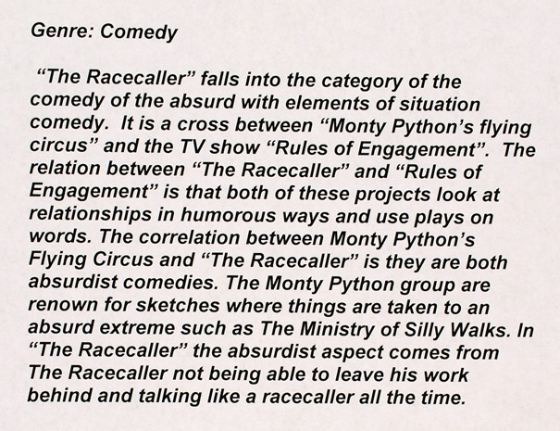
Relate the conventions of the genre back to your piece
Identify any sub genres it belongs to and describe other texts that are similar
By Jack Wynne: Season of Excellence
Others, use a combination of text and imagery
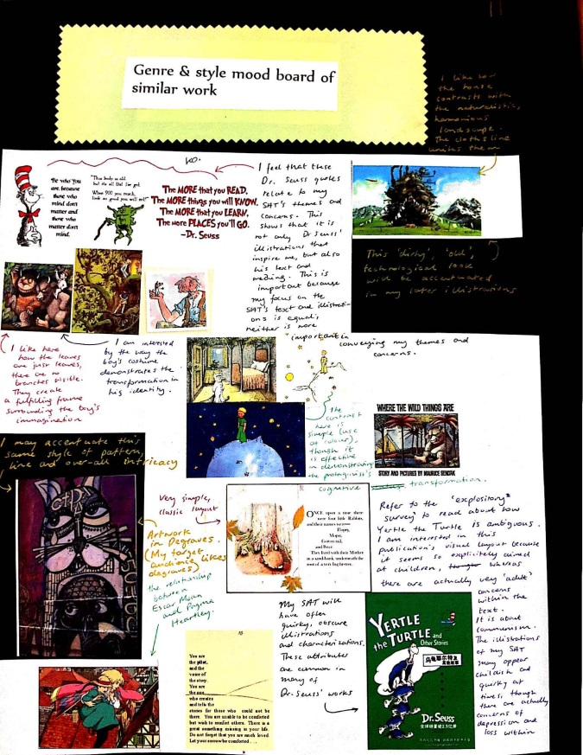
By Greta Giovinazzo, NHS Media
If you do this it is essential that you annotate the images that you have included and describe how they relate to the genre and/or style of your product.
By Isabella D’Souza, NHS Media

For the Film Makers
Script
This needs to be correctly formatted using standard conventions. Check out this link at script frenzy for an excellent summary on standard script writing.
Most professionals say that 1 page of correctly formatted script should equal 1 page of action in a film. So that gives you an idea of how long it should be.
You can also use freeware such as Celtx which helpfully formats the script for you! Download it here . Note, there’s a free version and a pro version and you only need the free version.
Storyboard
So storyboards often get a bad rep from naïve directors. Below is a great rationale for why you need a storyboard (along with the obvious, you can’t pass without one!)
Storyboarding has a variety of uses and one of those uses are why its so frowned upon by naive directors. That use is when a director storyboards just to visually check that the shots will cut together correctly and look like what he or she intends. Of course, since directors are total geniuses with minds of pure gold, they never have to double-check their own shotlist to make sure that the compositional elements will pan out as intended. That’s just crazy talk. A gifted visionary can see the whole movie in his or her own head, fuck storyboarding.
But for what it’s worth, sometimes it’s useful even to the director to look over the storyboards to remember how the whole thing is to be blocked and composed.
But one of the most significant uses of storyboard cannot be argued away by delusions of visionary-ness. And that is that if all else fails and you’re having a difficult time explaining the shot you want to your crew, you can grab the storyboards and point. “THAT, it needs to look like THAT.” Storyboards in this manner are essential for choreography, production design, special effects, and visual effects. Say you want a ninja fighting a dinosaur. The ninja will be shot in real life but the dinosaur is 3D. You need the storyboard so that you know where to frame the ninja when you’re shooting it so that you have room for the dinosaur.

The easiest way to design a storyboard is the old pen and paper, it looks like the picture below | You can always step it through with a camera if you are really opposed to drawing, however the downside of this is you need to organise yourself and mock actors for a ‘mini’ shoot.
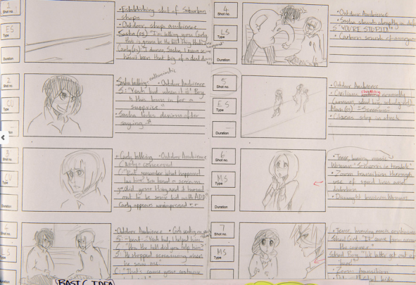 | 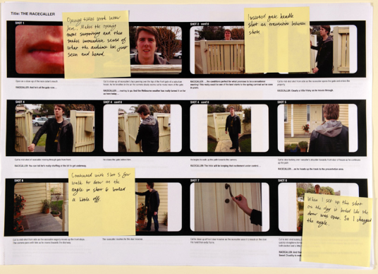

Some drawing tips

Stick figures are not acceptable but you don’t need to be a fantastic artist to draw a storyboard. What you want to convey is the shot size and angle along with the composition in the shot
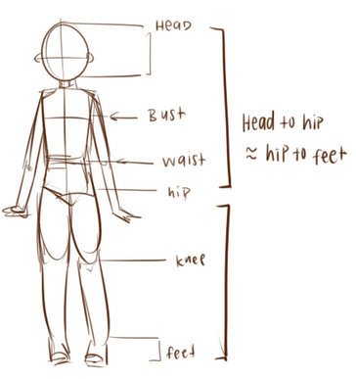 | Use circles and shapes to help build a figure
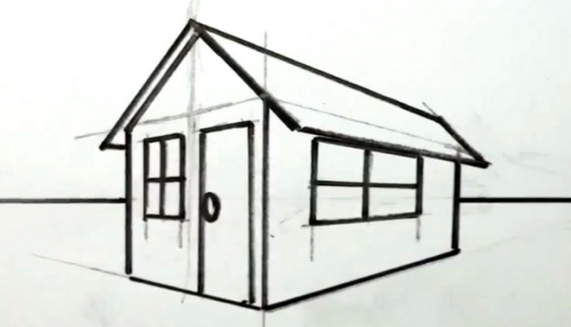 | Remember year 8 VCD? Good ole 2 point perspective? Very handy for drawing houses and buildings.  Just google ‘how to draw in 2 point perspective’ for a refresher

Indy Mogul even have a video about how to storyboard when you’re not great at drawing which you can watch here

Students often ask “how detailed does my storyboard need to be?” and “do I have to draw every single shot?” The answer to these are, the more detailed the better and the closer you come to every single shot the better. Of course things will happen spontaneously while shooting which may change your storyboard, this is a natural part of the process and you just jot these genius ideas down on a post it and stick it in as you go.
Detail in your storyboard is a great way to distinguish yourself from other students. Those that do a simple job are demonstrating basic skills and this can impact on the effect of their overall PDP. Those that do a thorough and detailed job are demonstrating stronger skills and this has a very positive impact on the overall PDP.
Low | Approximately 5 pages
Average | Approximately 10-15 pages
Superstar | 30+

Shotlist
You’ll probably find that your shot list is a real life saver and for many students it’s the document that they refer to the most during the production of their film. A shot list is basically a long list of all the shots in your film. You can use this great excel spreadsheet found at www.lessonbucket it’s really useful because it’s pre-formatted and you can sort your shots by location etc. for ease of shooting.

Ok, so that’s an outline of some of main components of your PDP but there are many more in the coloured list that you need to include. For help I would suggest that you check out past PDP’s from students at http://www.atomvic.org/season-of-excellence/2012-design-plans/

