NAME, DESCRIBE, LINK
This is the mantra to help you write analytical statements about film.
As the editing of the jolting jump shots that create the distorted montage in the nightclub scene communicate the idea that Nina’s sense of reality, like the editing, is chaotic and confused. This establishes her mental instability and the narrative possibility that her understanding of fantasy and fiction will soon collapse.
ORIENTATE the scene which you are analysing
NAME the element
DESCRIBE the element using a) film language b) adjectives
LINK to your analysis a) why the director constructed this b) what impact it has on the audience
Linking phrases:
a) Why the director constructed this
This suggests…
This establishes the idea…
This constructs the…
b) What impact this has on the audience
This evokes…
This allows the audience to understand…
This conjures the idea…

1. Camera Techniques:
Camera techniques refers to how the camera is positioned to capture a scene, and the techniques and qualities that are used. It may be from different angles, or from a distance, or it may be moving. It is also about the depth of field, focus, shot selection and film stock.
There are FOUR sub elements that make up camera techniques:
Shot types: This is the size of the shot
KEY WORDS: Camera shot types: establishing shot, long shot, medium shot, close up, extreme close up.
Camera movement: This is how the camera moves.
Camera movement: zoom; tracking/dollying; tilt (up or down); pan (left right, right left)

- The camera tracks Nina as she dancing, allowing the audience to feel as though they are dancing with her.
- The tracking movement helps the character to grow larger in the frame which increases their visual significance…

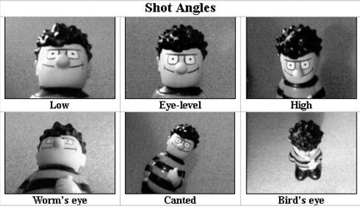
Camera angles: This is the angle of the camera.

KEY WORDS: Camera angles: high/low/bird’s eye view
Example Sentence starter: The camera angle helps the audience to see that this character is inferior/superior/fearful/in control/weak/strong/vulnerable.

Focus: The parts, (all of some) that are in focus.

Key words: large/small focal range; deep/shallow depth of field

Example Sentence starters: The viewer’s eye is drawn to the point of focus in the frame
- The focal range of the shot is deep allowing the audience to view all the action in the frame…
- It is important that the depth of field is shallow, as this allows the audience to view the scene through Joel’s perspective…

2. Acting
Acting refers to specific characterisations, traits or associations that an actor will add to the character to create a personality. It includes: body language, facial expressions, appearance, movement and casting.
There are SIX sub elements to ACTING:
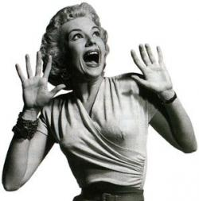
Body language: This is how the actor communicates with their body.
Facial expressions: This is the expression that the actor creates emotion on their face.
Appearance: This is the physical appearance of the actor.
Movement: This is how the character moves in the scene.
Voice: How the actor manipulates their voice to convey meaning.
Casting: This is the association that the particular actor has.
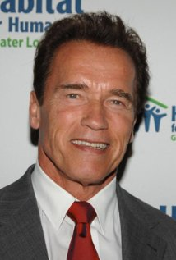
For example, Arnold Schwarzenegger is often cast in action films, as the hero.
So audiences viewing a film with him as the start would have these expectations.
Key Words:
Voice (volume, pace, pitch, timbre, rhythm)
body movement (jerky/languid/over exaggerated gestures)
Facial expressions (wide eyes, scrunched brow, squinted eyes)
Body language (slumped shoulders, confident posture)

3. Mise en Scene
Mise en scene is the way a scene, or particularly a frame is set up. It is how the director places the characters, props or setting to create a look. Take into consideration: colour, costumes, lighting, shots, setting, camera techniques.
Because mise en scene is EVERTHING you can see in the shot, there are many sub elements here are the obvious ones.
SYMBOLS: The symbolic meaning behind anything in the frame.
COLOUR: The associated meaning of particular colours.
LIGHTING: See production element
CAMERA: See production element
SPACE WITHIN THE FRAME: How characters and objects are positioned in the frame.
PROPS/SET: The objects in the frame and the location of the action
COSTUME/MAKEUP: What characters are wearing, how they are wearing it and their hair and make up.
SENTENCE STARTERS:
The audience interprets the arrangement of objects and subjects within the frame to mean….
- Audiences can interpret the visual composition of the frame to mean….
- The arrangement of objects in the frame makes it clear that…
- The composition of the visual elements helps the audience to understand that…
- The symbolism in this arrangement of objects is that…
- It is symbolic of…
- The costuming, as well as lighting and composition, tell the audience that…

- 4. Editing
Editing deals with the way shots and sound are put together, or cut to create the effect that the director wants. It is about placement of scenes, timing, pace and rhythm and the relationship between vision and sound.
Cut: A change from one shot to another
Fade: One shot fades into another or into black or white or (rarely) colour
Dissolve: One shot dissolves into another
Wipe: One shot wipes another from the screen
Jump cut: A cut from one shot to another that does not match visually (loss in continuity)
Action match: The opposite of a jump cut, this cut creates spatial and visual logic between shots, making the action appear smooth
Eyeline match: A cut from a character looking at something to the object being looked at; also refers to the matching of the way characters fill the screen in shot/reverse shot editing
Shot/reverse angle shot: The second shot looks back from where the first shot originated; often used when editing a conversations; may include over-the-shoulder shots.
Cross-cut or parallel editing: cutting between two sets of action occurring at the same time but in different locations
Cutaway: The shot is related to but not part of the action
Cut in: A cut to tighter framing of the action
Superimposition: The addition of text, images or symbols over footage
Ellipsis: The foreshortening of plot duration, ie editing out parts of the story to condense time but to also allow audience to imagine what might have happened. Narrative logic often allows the viewer to disregard an ellipsis.
Manipulation of speed: Altering the speed of action by slowing it down or speeding it up
Montage: Repaid editing to create a strong visual impression from a variety of shots, which may be used singly or in repetition

Sentence starters:
- The selection and placement of shots through editing helps the audience see that…
- The sound and vision have been edited together in a way that demonstrates that…
- The relationship between the vision and sound editing creates a quick pace for the scene…
- The rapid cuts in editing help create a fast/swift/steady pace for the scene…
- The cuts increase in frequency making the shots shorter and thus creating a steady rhythm and sense of urgency…
- “The shots in the scene in the bell tower are very short because Hitchcock has cut the vision very quickly to increase the pace of the scene and increase suspense for the audience..”

5. Lighting
Lighting is how the lighting of the narrative is constructed, it involves creating realistic light, shadows, emphasising objects and people within a scene, natural lighting, and expression and setting a scene. It can also be used to create mood and tone.
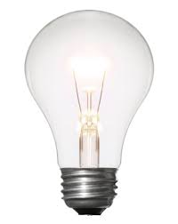
Low Key
Creates strong contrast and emphasises sharp and deep shadows.
Expressive
Construction of the lighting design intended to deliberately and non-naturalistically emphasise or draw attention to mood, character, location, ideas and/or themes.
High Key
Refers to a bright and evenly lit scene with few shadows.
Naturalistic
Artificial lighting that simulates what audiences would expect to see in the real world and constructs a sense of realism in a text.
Shadows
constructed through purposeful lighting, this may cause paranoia, fear, suspicion, or convey ideas about a character or mood.
6. Sound
Sound is everything that can be heard. This includes sound track, music, sound effects, diegetic and non diegetic, dialogue, pitch, timbre, duration, rhythm and silence. It is used to create mood, atmosphere, convey emotions of characters.
Diegetic Sound: Sounds that exist ‘within’ the film world – as in, a character can hear it
For example: Dialogue, a character listening to a radio, a bomb exploding,
Non-Diegetic Sounds: Sounds that exist ‘outside’ the film world – as in, only the audience can hear it
For example: narrator, soundtrack
The Absence of sound is also important and used on purpose to convey meanings and messages.
Elements of Sound:
Volume: The volume of a sound is how loud it is.
Pitch: Is how high or low the frequency of a sound is. (eg. The pitch of a scream is high, while the pitch of thunder is low)
pace: the speed of music
Music; Dialogue; Sound Effects; Absence of sound
Diegetic (‘inside’ the film world); non-diegetic (‘outside’ the film world)

Music:
- Tempo (‘beat’ or ‘speed’- fast or slow)
- Instrumentation (which instruments have been used – string, horns, woodwind)
- Articulation (legato [smooth] or staccato [short], pizzicato [plucking of strings])
- Dynamics (crescendo – getting louder), decrescendo (getting softer)
- Key (Consonance [harmonious – major key] or dissonance (clashing notes – minor key, sounds harsh or unpleasant])
- There are many repetitive musical motifs (symbols) in Bernard Herrmann’s score in Vertigo…
- The musical themes/motifs recur through the text to help indicate a mood…
- The musical tune becomes a theme of reconciliation/confusion/romantic love, as the audience hears it repeated in several scenes…
- The music can suggest meaning to the audience…
- …the music matches the climactic moment…

Dialogue:
- The dialogue between the characters “_______________” helps the audience see that their communication is stifled and their relationship is unstable/rocky
- The narration helps the audience learn more about Joel’s inner feelings as he says “_____________”
- The narration positions the audience to understand the narrative subjectivity, from the point of view of the narrator, Joel.
- The inclusion of the dialogue “_______________” demonstrates that she in fact wants to…

Sound effects:
- The sound effects reinforce the onscreen action as Scottie climbs the tower his footsteps…
- The sound effects have been used to alarm the audience…

