NAME: __________________________
VCE MEDIA STUDIES
UNIT 3 & 4
SAT
Individual Production with PDP
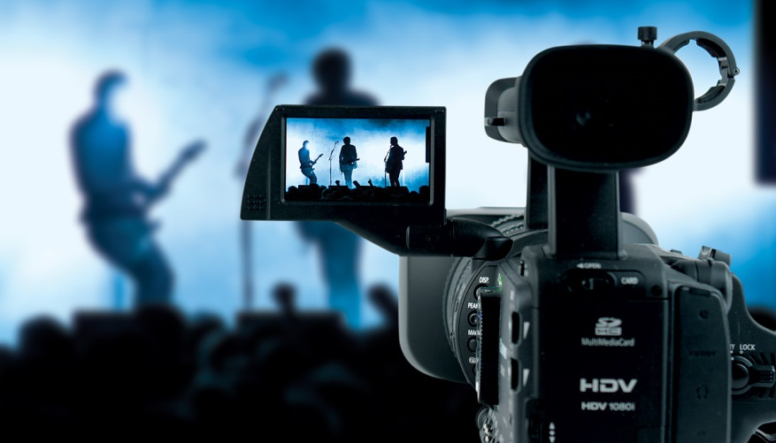
TASK
You are to individually design and produce a 3-10 minute video or film sequence, including title and credit sequence.

You will be required to submit and be marked on:
Unit 3, Outcome 2 Media Production Skills
Unit 3 Outcome 3 Media Production Design
Unit 4, Outcome 1 Media Process

The production aspect of unit 3 & 4 Media makes up 37% of your final study score and is made up of three components.

Important Information
AUTHENTICATION
VCAA authentication requirements see that the entire SAT process is overseen by your teacher. You will be required to show your PDP to the teacher in every SAT allocated class. You will also be required to complete some of the editing process at school.
ORGANISING YOUR TIME
This is a big project that needs to be organised and executed in a logical manner. Dedicate a certain amount of time to your SAT every week. As we get closer to the submission date, you will also be expected to stay back after school in order to work.
BORROWING OF EQUIPMENT
Borrowing the school equipment is a privilege and a right. Please book equipment by checking availability with Ms. Alexander. Failure to follow school equipment guidelines will see termination of borrowing privileges.
3.2 – PRODUCTION DESIGN PLAN
What is it? YOUR PDP

A Production Design Plan or PDP is a comprehensive design document media students are required to create that replicates the pre-production tasks performed by industry professionals prior to a shoot.

It acts as a “first draft” which your teacher can offer you feedback on in order for you to prepare yourself fully for the production phase.

The style, audience, and intention is to be designed by you, and should be clear in your PDP and final product.
TASK 1.2A
You need to prepare a production design plan for a your video product, designed for a specific audience of your choice. You are required to document every aspect of your planning stage. The list below details the very basics of what needs to be recorded in your PDP. Remember, a good PDP details every aspect of the creation of your media product, and is required to represent ideas and planning both written and visually. The following subheadings are suggestions of content that needs to be covered and will vary depending on the specific nature of your production. Speak to your teacher for further information or refer to PPTs on the Weebly.
DUE DATE:
Monday 15th June
SUGGESTED HEADINGS FOR PDP
•Cover page/ Contents
•Inspiration
•Ideas / Brainstorm / Thought process -
• Intention
• Target Audience – Including audience profile, how they will consume the media product and how you will appeal to them
• Research – Equipment, Genre (codes & conventions), locations, sfx, music, images, inspiration. You must document every bit of research you do and how it will affect your final product. It needs to be extensive and detailed.
• Character development (personality, costume, appearance, production/story elements)
• Locations - trial shots of locations, angles, discussion of location relevance and potential issues (traffic, lighting, travel etc)
• Equipment – a detailed equipment list (& budget if appropriate)
• Techniques of Engagement Relevant story and production elements- what you want and how you will achieve this
• Storyboards / Drawings of photos/ sketches of layouts
• Script / Screenplay/shotlist (include all drafts!)
• Timeline/ schedule – an overview and of important filming days
• Release documents – Location, talent, personnel, Music copyright
• Authentication form – This official form must be signed off on three times and included with your final production.
• Production exercises
• Call sheets
• Communications
**Please note that criteria 7 of the SAT is how you used the PDP as a working document for your final product and the realisation of your PDP in the final media product. Therefore you will need to consider how you will document changes made from the PDP to the final product. This could be done by leaving a small alterations box/section on each page, attaching post it notes during the production and post production stage, or an alterations table at the end that document the changes you made from your planning to the final product. Due to authentication you are not permitted to change the PDP after initial submission and no new or altered pages will be accepted.
The MUST DO list:
Your PDP is a documentation of ALL PLANNING for your production, therefore you can anything to it that is part of your planning. There are however, some essentials which you must complete.
Essential Component of PDP | In brief, what is it?  (more information can be found on the Weebly) | Check date
Brainstorm | A collection of ideas that may or may not impact your final product. You can brainstorm plot, production and story elements, genre, locations, music etc. | 27th March  (wk 9 term 1)
Research | Evidence of research of genre, film techniques, ideas, characters etc | 14th April  (wk 1 term 1)
Treatment | A brief outline of what your media product is. | 4th May  (Wk 4 term 2)
Script or A/V Script  (depending on your chosen form) | Written planning and documentation of what will be said on the screen. | 4th May  (Wk 4 term 2)
Statement of Intention | A detailed explanation of the purpose of your media product. | 4th May  (Wk 4 term 2)
Statement of Audience | A detailed explanation of the purpose of your media product. | 4th May  (Wk 4 term 2)
Production exercises | See explanation for 3.3 | Friday 22nd May  (Wk 6 term 2)
Locations/Props | A list of possible locations and props and a final justification. | 28th May  (Wk 7 term 2)
Techniques of engagement | A detailed brainstorm and list of how you will manipulate the production elements to create meaning. | 28th May  (Wk 7 term 2)
Equipment | A list of your equipment | 28th May  (Wk 7 term 2)
Shot list | A list of the shots you will need to capture | 8th June  (Wk 9 term 2)
Storyboard | Visual representation of a scene that is either important or will be difficult to film. | 8th June  (Wk 9 term 2)
Timeline | A schedule of when production will take place | 8th June  (Wk 9 term 2)
PDP | Entire PDP | 10th June  (Wk 10 term 2)
Draft screening: (13th August)
A draft screening is when we present the rough cut (a rough edit of our media products) media products to the class for feedback. This is essential in picking up on things you may have missed, and give you a chance to fix them before submission.
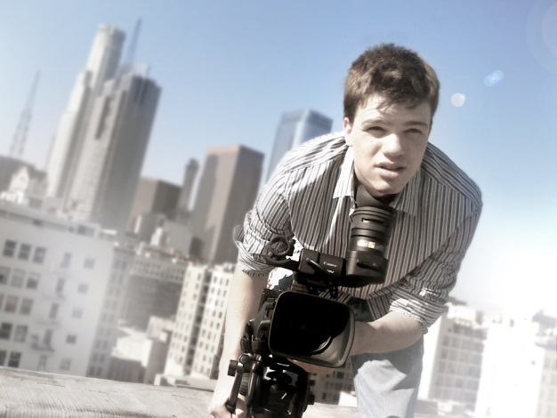
3.3 – MEDIA PRODUCITON SKILLS
What is it? YOUR PRODUCTION EXCERSCISES

Production exercises act as an opportunity to have a practice, trial run or even conduct an experiment that will give you a chance to try something out before you commit to including it in your final product. What you focus on is up to you, here are some suggestions:
- Focus on a particular production element and how you will use it to your advantage.
- Focus on a particular emotion or idea you wish to communicate and how you will construct this
- Focus on an ‘at-risk’ area of your production that you are not sure how to
execute.
For each production exercise you are required to complete the following:
1. Intention:
Outline the purpose and intention of your production exercise. You will need to discuss:
-The purpose of the technical exercise. (Consider the role that the technique will play in your final product)
-How you will achieve this (Consider the steps you will take, how you will demonstrate a technically accomplished exercise, what effect you wish to achieve)
-What equipment you will use (Consider the possibilities and limitations the equipment may present)
2. The technical exercise:
You will need to submit evidence that the technical exercise took place, this could mean submitting 20-30 seconds of edited footage or sound.
3. Evaluation:
You will plan, undertake and evaluate two separate production exercises to develop skills appropriate to the technical equipment, applications and media processes available to them. Therefore you will need to complete the below process twice, however they are separate and the two exercises do not relate to each other. Each media production exercise is accompanied by a statement of intention, evidence of the exercise and an evaluation specific to the exercise. Think about this as an experiment, or a trial run, you could focus on: how to communicate an idea, achieving a particular effect, explore aesthetic quality, use a new editing/filming technique etc…

Please note that no material from your production exercises can be used in your final product.
DUE DATE:
Friday 22nd May 2015
Link your exercise with your intention and discuss:
- The successes and failures you encountered
- How you overcame difficulties (What strategies you used and how you solved problems)
- The possibilities and limitations the equipment presented (evaluate the equipment, and your use of it)
- What you learned from the process (How that will influence your final production)
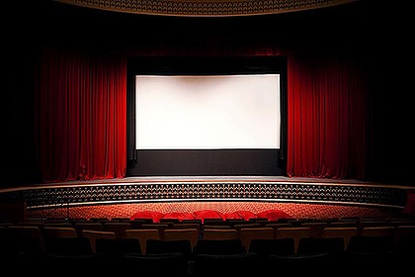
4.1 – MEDIA PRODUCITON SKILLS
What is it? YOUR FINAL PRODUCT

It is encouraged that you work with others so that you can use each other during the production. This will allow you to take it in turns to assist for your friend’s production. However, according to the VCAA you must be the director of the media product.

Please note that this, like all of the stages requires excellent organisational skills. You need to allocate time to film, edit and for a ruely quality production, go back and reshoot or gather more shots and scenes.
DUE DATE:
Thursday 20th August
*** Please note you are required to submit your production and the PDP on this date. Only pages that have been previously submitted and stamped will be accepted, no new material, besides production and post production notes will be accepted. You may mark (as mentioned previously) changes or difficulties you faced while filming. For example on your shotlist you may cross out a few shots and make a small note next to it commenting on how the weather, or actors etc did not allow you to successfully film that angle.
You will now complete the media product based on a media production design plan completed in Unit 3. You must use your PDP as a working document throughout the production and post production stages. You will need to document changes, alterations and problems that rise and how you deal with these issues.

