We have just learnt and discussed some of the basics of advertising, in particular differentiation, demographics, and desire.
In your workbooks, for each of these products below write down and explain how the product could:
a) Differentiate from similar products
b) Which demographic or demographics the product would appeal to
c) How the brand could create a sense of desire
Bottled water
$2.50
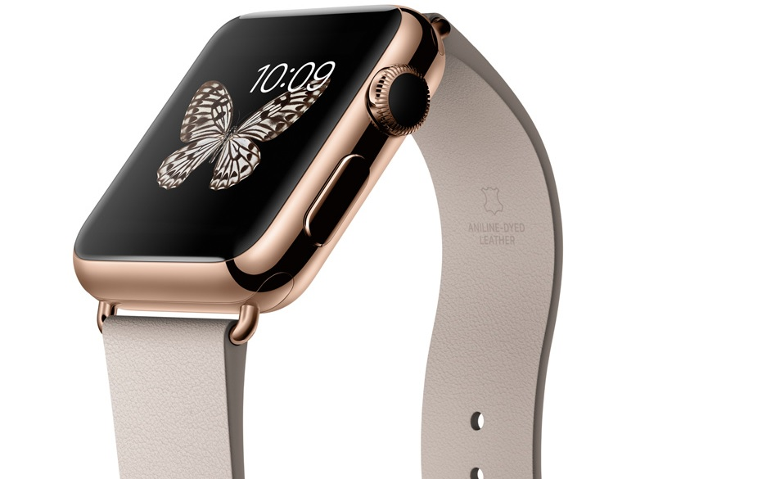 | Apple Watch  $1500
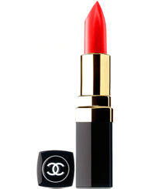 | Channel Lipstick  $90
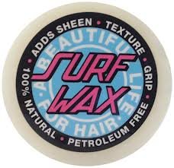 | Surf Wax  $2
Barbie
$29.95
Tonka Truck
$39.95
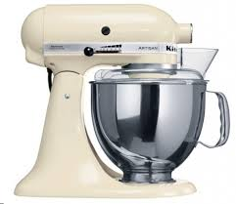 | Kitchen Aid Mix Master  $699
Choose your own product!

